1. Pick a car make/model of your choice: **Jeep compass**

2. Select 2 different cities (locations) that you are interested in.: **Boston and New York**

3. Get the prices for the car model/make of your choice using the webscraping code for both the cities

**Boston**

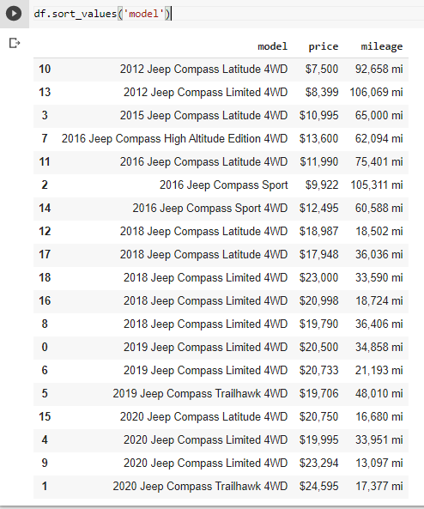

**New York**

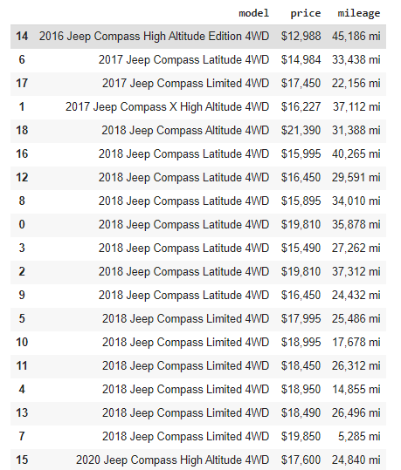

4. Compare the depreciation of the model you selected across the two cities and the average price point.

In the Boston dataset, about 60% used car are built after 2018. And some of them are built in 2012. But for New York, 83% used jeep compass are built after 2018. And the oldest car in this data set are 2016. But the average price for both cities are similar.

Boston average price $17519

New York average price: $17540

5. Write a competitive intelligence report based on your code and what would be your recommended price for a 3 year old car of each model in both the cities.

**Boston 2018 jeep compass mean price: $20206**

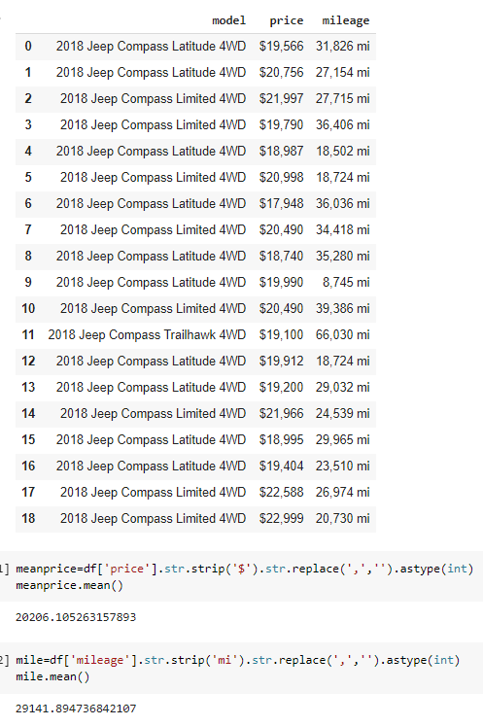

**New York 2018 jeep compass mean price: $17855**

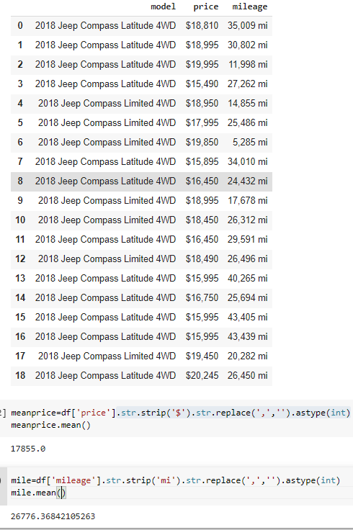

After we scrip the data from the website. I found for jeep compass, even if the situations are similar, the price in Boston is higher than New York. Sometimes a low-mile car in New York are even cheaper than a car in Boston which has a higher mileage. So, I think for the company in Boston, we should set a price which is a little bit lower than the marketing price. So, we can attract more people and still can earn enough profits.

For the company in New York I think we should set a normal price. Because I don’t think we can have advantages in price, so we should find another way to attract people. for example, we can provide more service to customers, we can give them several times free maintenance. Or we can provide them with a free check for the car or towing service. These services won’t cost a lot but every customer may want them.